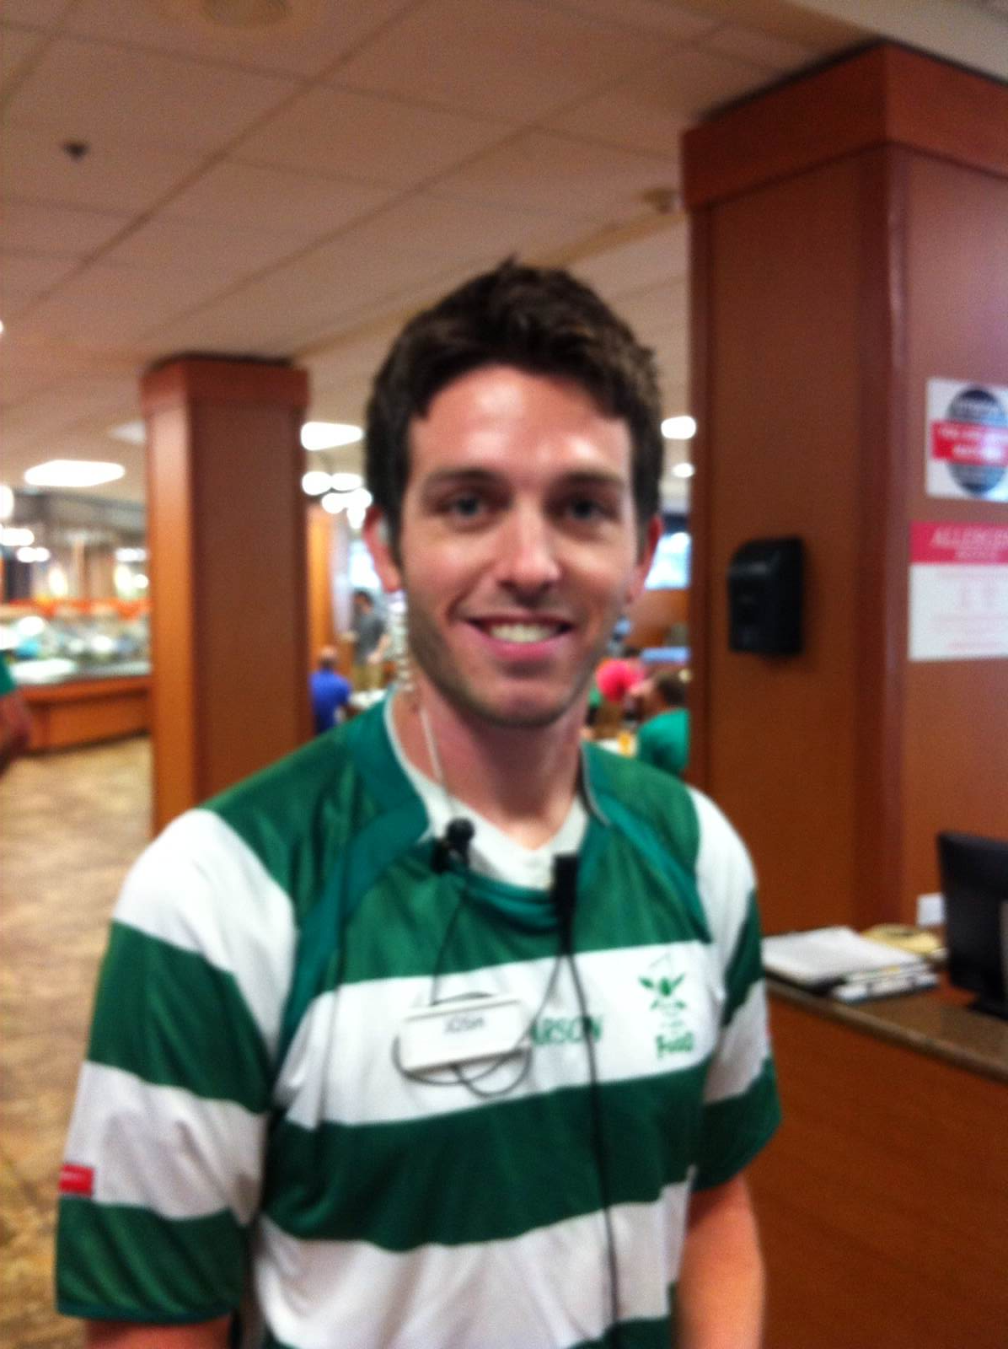

Wow: worker of the week

First impressions are important.  In the cafeterias, our cashiers are our first line of top-notch service.  At Kerr Cafeteria, Josh Pettett is raising the customer service bar.  Josh is friendly, fast, and informative.  Because of Josh’s outstanding customer service, the first impression of Kerr is a great one.  Thanks for all you do Josh; you are appreciated.

Work tip

Do you know who employers hire?  My neighbor is a director of a financial services firm in downtown Dallas.  He and his partners are SMU graduates.  They usually only hire SMU grads.  Last year, they hired one UNT graduate.  This year they upped the ante and hired 3 UNT graduates.  He recently told me that the firm is seriously considering hiring only UNT graduates.  He said the UNT students were just as sharp as the SMU grads….but he said the UNT grads have two qualities that stand out: work ethic and attitude.  Those two qualities are not learned in the classroom.  They are learned in the dining room, in the kitchen, in the dish room and at the cash register.  Treat your part time job with us like the training ground it is.  It makes a difference to your future employer.

WHAT’S GOING ON

It’s Week 5 of the Fall ’14 semester.  The Fall semester is always the busiest of all.  It is difficult to keep up…but we have to do more than keep up….we have to improve.  We have lots of hungry students depending on us each and every day.  This week our new president will give the state of the university address, we will have the board of regents on campus, we have a football game and it’s parent’s weekend.  That’s a busy schedule on top of a full plate.  Our job is to make sure everyone gets great tasting food at each event….whether it is another lunch in the cafeteria or a black tie affair for the campus VIPs.  Let’s stick together and work fast.

*If you want work well done, select a busy man; the other kind has no time.*

*— Elbert Hubbard*

SEPT 15, 2014

VOLUME 7 ISSSUE 3