Do you want to be part of the Hospitality Industry?
ProStart is a Culinary Program for high school students that develop the best and brightest talent into tomorrow’s industry leaders. From culinary techniques to management skills, ProStart’s industry-driven curriculum provides real-world educational opportunities and builds practical skills and a foundation that will last a lifetime!
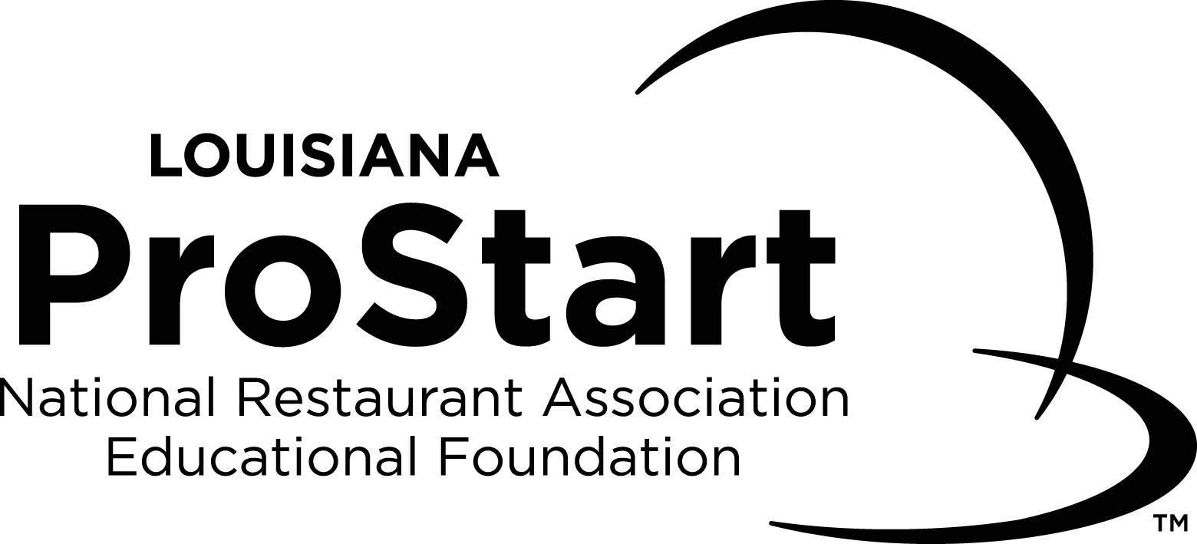
MISSION
- To unite industry and classroom to create a unique and unparalleled experience for students
- To set a high standard of excellence for students and the industry overall
- To offer life-changing opportunities for students and provide direction for potential career paths
- To develop tomorrow’s restaurant and foodservice industry workforce
- To provide Certifications to students to better prepare them for their future
- To align classroom courses to college curriculums to give students a jump start into their future

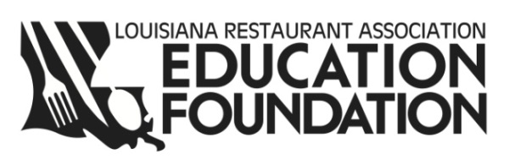
Check it out:
www.nraef.org/ProStart
www.goprostart.com

Real life experience
Real life exposure
Real life success

