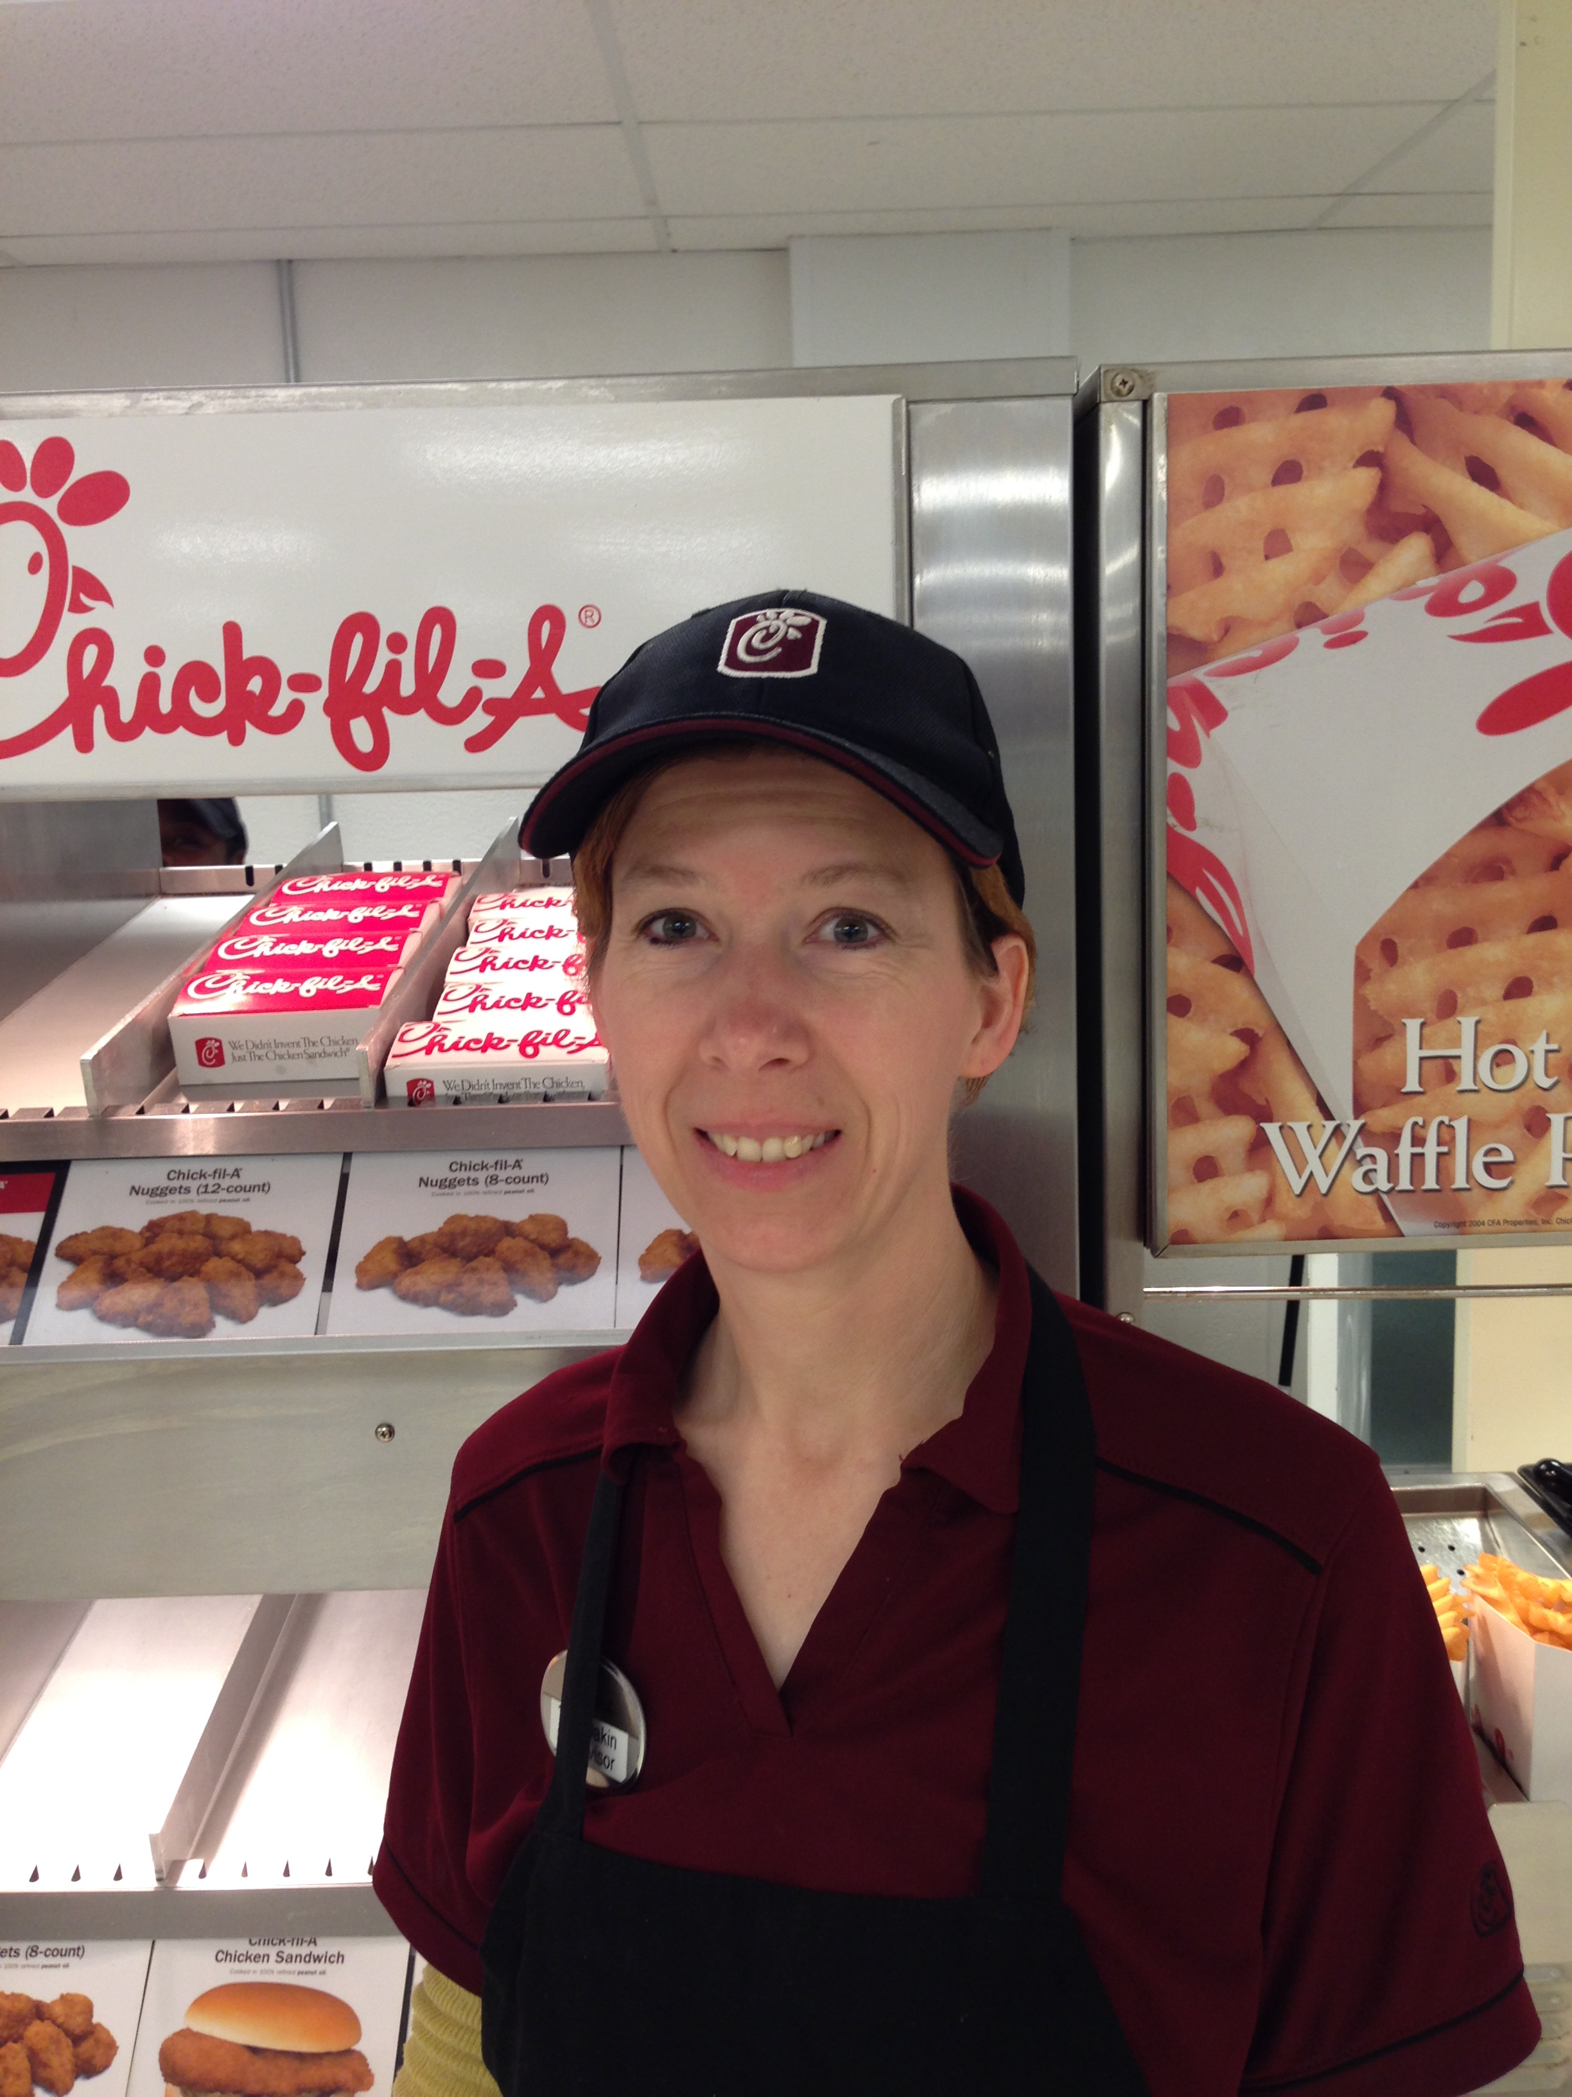

Work tip

Did you know you are probably an average employee?  Come to work on time, in the uniform, know how to perform reasonably well?  That’s average.  The above average employee brings a little more.  One trait of the above average employee is *anticipation*.  He or she *anticipates* what is needed, then gets busy doing it.  No waiting to be told, supervised, or cajoled.  The above average employee thinks, then acts.  The secret is it usually only takes a *little* thinking to make a great big difference.

Wow: worker of the week

The worker of the week for Retail Dining Services is Tara Dakin our supervisor at Chick Fil-A.  Besides supervising the busiest concept for Retail Dining, she has been working extra duties with the absence of one of her co-workers.  Tara insures that we are always in Brand compliance as well as in house compliance. She has a genuine drive for perfection and a sincere knack for hospitality.  Tara ensures a great product, great service, and a sparkling clean concept.  We are proud to pick Tara as the Worker of the Week, and we appreciate her “Can Do” attitude week in and week out.

WHAT’S GOING ON

We are moving full speed into October.  Now is the time to crank up the special themes in the cafeterias.  Go all in.  Authentic food should be the star.  But, don’t forget the décor, the theme, the music, service.  Make sure we engage all of the senses.  I really like our food.  But I only eat here once or twice a day.  Our main customers eat here all day, every day…including weekends.  It can get boring very quickly.  Let’s kick it up!

*Instruction in youth is like engraving in stone.*

*— Old African Proverb*

SEPT 29, 2014

VOLUME 7 ISSSUE 5