Dimension and Height
An important part of any presentation is height or dimension. Without it the plate may look flat and unappealing. Height enhances the focal point and draws attention to that area on the plate. It takes thought and preparation to accomplish a three-dimensional presentation using only the flavor- and texture-compatible ingredients that belong and also maintain ease of service for the guest. For example, relishes or marinated vegetables are sometimes used as a ramp to elevate slices and give added dimension. Salads can use unique vegetable cuts, bound greens, or seasoned croutons to achieve height. Entrees and appetizers can use the natural shapes of bones such as a chop or breastbone. Molded or shaped starches or vegetables such as potato pies or turned vegetables, can also add height.

Serviceability
This term refers to how easy it is for guests to serve themselves from the plate. The guest should not be forced to move items or garnishes around in order to reach the food that has been provided. Care should be taken during layout to make sure guests can reach and cut their food with the greatest possible ease.

Slicing
Slicing is a commonly overlooked yet extremely important technique. Incorrect execution of the basic fundamentals of slicing results in a plate with a confused, unorganized look. Strong lines become ineffective if the slices themselves are of different thicknesses or are cut at different angles. Also, if care is not taken to arrange the slices on the plate in the same order in which they were cut, the result will be a less than professional look with weak lines that detract from the product. Even and consistent slices that are properly arranged make executing strong line presentations easier and more attractive.

Balance
In years past, balance was synonymous with symmetry. In recent years, we discovered there is more to balance than just symmetry—there is also balance by weight, which allows for tremendous variety. For example, if you were to balance yourself standing on one foot, there are many different positions your remaining leg and two arms could be in. The key to being balanced, however, is to keep the appropriate amount of weight on each side of your supporting leg. The same principle applies to plate presentation. Imagine the plate divided into quadrants, and make sure weight is evenly distributed between them.
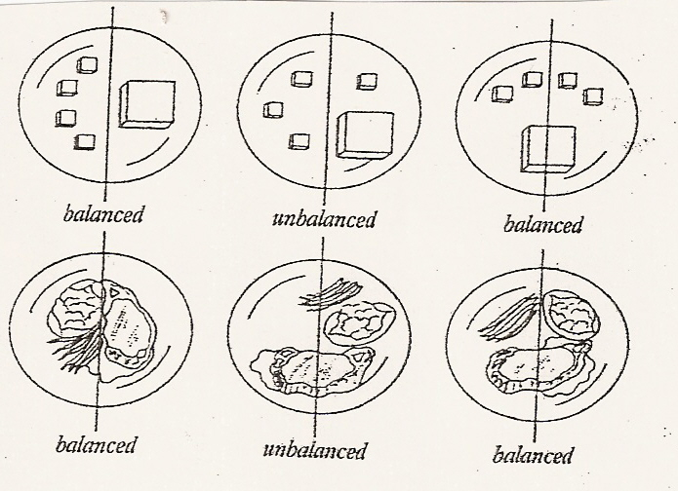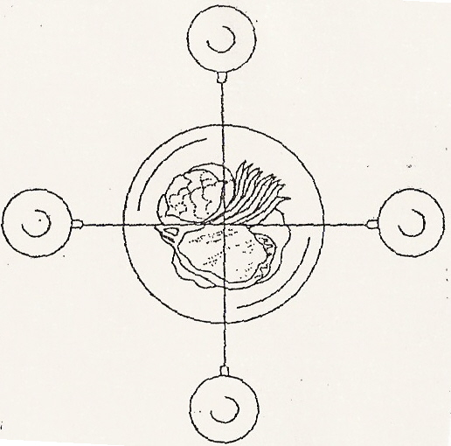
Line
Line is important to eye appeal because it, too, exerts a psychological effect. Lines can be labeled strong or weak. The stronger the line, the more the eye is drawn to it. Food often dictates the use of strong lines in its presentation, which is not surprising if you consider the way we look at food itself. Take an apple, for example. When the apple is fresh, it has clean, strong lines. As it deteriorates, it picks up more and more weak line characteristics. In this way, strong lines also enhance the perception of freshness.
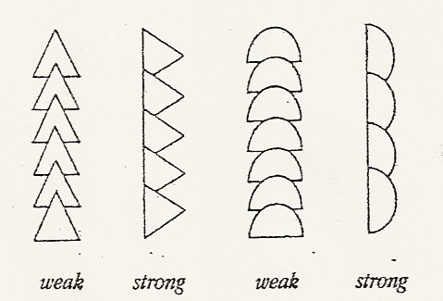
Layout
Line and balance are important, but to be effective they must relate to the overall continuity of the plate. For example, if you have a plate with several strong lines working against one another, you’ve created a presentation that is uncomfortable to look at. Layout must take the following points into consideration:
- What do you want the guest to see first?
- What is the theme of the plate and the meal?
- Where is the expense or cost on the plate?
The answers to these important questions will dictate the focal point of the plate presentation. You must establish a focal point before the principles of balance and line can be applied. For example, one would want the most expensive part of a plate, usually the meat of fish, to be the focus of attention. Use line and layout to design a presentation that would draw the guest’s eye to that part of the plate. All lines should rotate back to the focal point. By using this manner of presentation, you are able to guide the guest’s eyes to the area you want them to see first. The layout should be natural in line and shape and should tell the guest something about the theme and contents of the plate.

