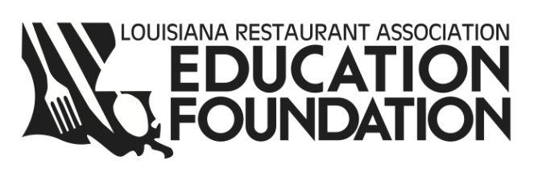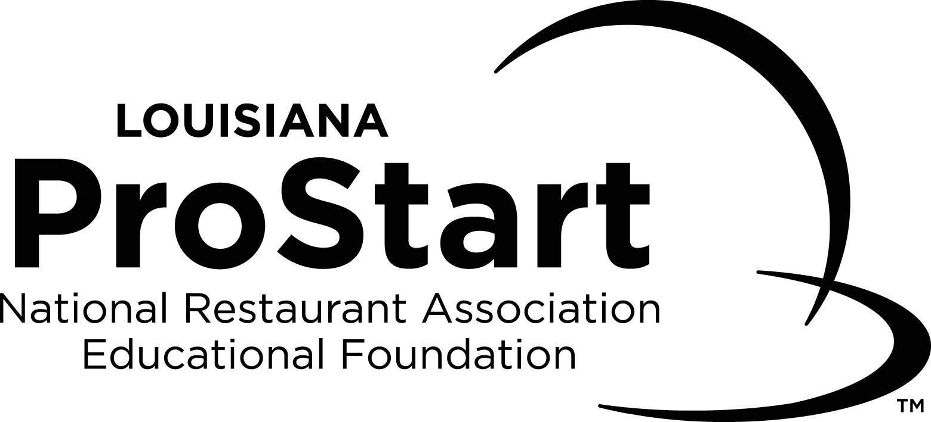

ProStart® is a nationwide, two-year program for high school students that develop the best and brightest talent into tomorrow’s industry leaders. From culinary techniques to management skills, ProStart’s industry-driven curriculum provides real-world educational opportunities and builds practical skills and a foundation that will last a lifetime.

By bringing industry and the classroom together, ProStart gives students a platform to discover new interests and talents and opens doors for fulfilling careers. The curriculum teaches all facets of the restaurant and foodservice industry, inspires students to succeed and sets a high standard of excellence for students and the industry. ProStart is supported and operated by the Louisiana Restaurant Association Education Foundation in partnership with the National Restaurant Association Educational Foundation. With over 40 high school programs and 1,200 students, the ProStart® program has become a talent pipeline for careers in Louisiana’s world-renowned foodservice industry.

ProStart’s Mission
- ProStart unites industry and classroom to create a unique and unparalleled experience for students
- ProStart sets a high standard of excellence for students and the industry overall
- ProStart offers life-changing opportunities for students and provides direction for potential career paths
- ProStart is developing tomorrow’s restaurant and foodservice industry workforce

Who Are ProStart Students and Educators?
- ProStart serves students in all types of communities, from rural to urban schools
- Students participate in ProStart as an elective track in traditional high schools, career and technical centers, vocational high schools and Department of Defense schools
- Educators range from family and consumer sciences educators to chefs who transitioned from industry into the classroom

ProStart National Certificate of Achievement
The ProStart National Certificate of Achievement is the culmination of the ProStart program. To earn this industry recognized certificate, students complete the two-year program, pass two national exams and work 400 mentored hours. Students who achieve the certificate are eligible for NRAEF and LRAEF scholarship opportunities and course credits at more than 75 of the country’s leading hospitality and culinary arts colleges and universities.

Demand for ProStart
- The foodservice industry is the largest private employer in Louisiana
- ProStart students are more employable and have greater opportunities to advance in the foodservice industry
- Post-secondary schools strongly recruit ProStart certified graduates offering college credit and scholarships
- Created to address the demand for the next generation of leaders in our industry

