Menu Engineering | Food Cost Control
Several of our previous restaurant cost control articles have been dedicated to the topic of recipe cost and menu development. This article will continue on that trend by examining the principles of menu engineering and how they can help improve restaurant profitability and food cost control. Today's concept of menu engineering is a product of Michigan State University's School of Hospitality, and the goal of the exercise is to comparatively rank your menu items according to both profitability and popularity and to then graph these results using the BCG Matrix. This matrix utilizes four quadrants, and though the names have changed a bit during their application to the hospitality industry, their meaning has remained generally consistent.
Quadrant Definitions:
"Stars" are those menu items that are both the most popular and the most profitable. These are often house specialties and are the menu items that you want to sell most frequently due to their high contribution margin.
"Plowhorses" are menu items that are above average in popularity, but not in profitability. Overall, these items produce consistent profit for the business, but are not stars because their contribution margin is below average.
"Challenges" are the converse of plowhorses. They are highly profitable menu items, but not very popular.
Finally, "Dogs" are those items that are neither popular nor profitable, in comparison to your other menu items. Serious consideration should be given to eliminating these items from the menu.

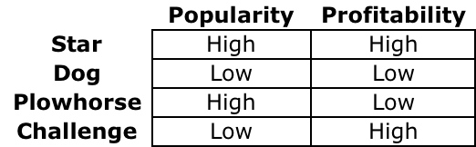

The Mechanics of Menu Engineering:
To determine the correct quadrant for each menu item, menu engineering looks at both the average popularity and contribution margin of your menu items. Based on the results, each menu item is plotted on a graph, using the average profitability and popularity as the x and y axes. Each quadrant corresponds to a particular menu engineering label, as illustrated below. While menu engineering labels can be assigned to menu items without actually completing a graphical representation, we do not recommend this. Completing a graphical menu analysis in addition to simply labeling each menu item with the appropriate quadrant tag will provide a more exact and complete picture into how each menu item ranks in comparison to others. A plotted menu item that is on the border of another quadrant may require a different approach than one that is firmly situated in a specific quadrant--a subtlety that is only noticeable when menu items are actually plotted on the graph. While this may seem complicated, it can actually be quite simple once you become familiar with the process.
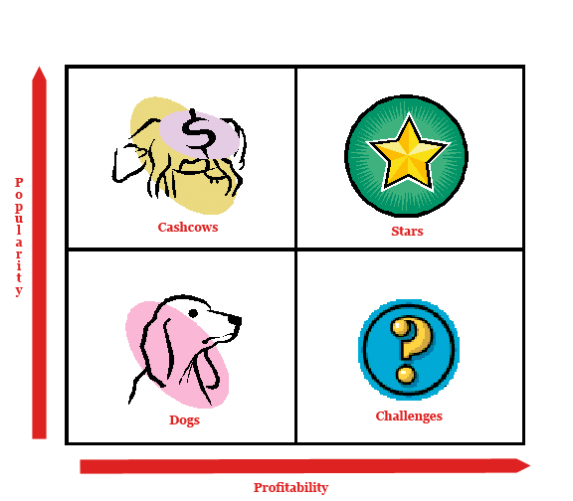
Popularity
Determining the average popularity is relatively simple; just take the reciprocal of the total number of menu items, expressed as a percent. For example, if you have twenty menu items, the average popularity would be 5% (1/20). Any menu item that represented more than 5% of the overall product mix sold would be considered a popular item, making the item either a star or a plowhorse, depending on the contribution margin of the item.
Profitability
Menu engineering uses contribution margin as the metric for defining profitability. To calculate the contribution margin of each item, one simply needs to deduct the ideal food cost from the menu price for each menu item.
For example:
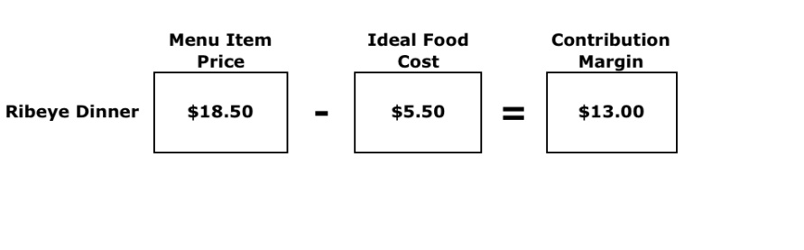
Once the contribution margin is calculated for each menu item, the average can be easily calculated--divide the sum of each menu item's contribution profit by the total number of menu items. Any menu item that has a contribution margin above this average would be considered "profitable," making it either a challenge or a star, depending on the popularity of the item. Some schools of thought advocate the use of prime costs in contribution margin calculations, including incremental labor costs into the food cost figure, but unless this is a typical internal cost accounting practice for your operation, we do not recommend it.
Once you have determined the comparative popularity and profitability of each item, you can then graph the results using the specific calculations into a four quadrant graph and identify each item with the corresponding matrix label, as discussed previously. You can also develop your own restaurant spreadsheet with a little work or purchase one from various restaurant consultant agencies. Once this process is complete, however, the real work begins.
Analyzing the Results of Your Menu Analysis
The primary benefit of using menu engineering as your menu analysis tool is that after only a little preliminary work and calculation, you are able to get an in depth picture into how well your menu items perform in comparison to each other. With this information in hand, it becomes much easier to make strategic menu decisions aimed at improving restaurant profitability. Further, the repetitive use of menu engineering over a period of time will help you gauge the effectiveness of past menu decisions, such as price changes, re-formats, deletions & additions, position changes, etc.
Challenges: A Few Suggestions & Solutions
As we discussed before, challenges are those items that have a high profit margin, but don't sell very well. Because of their high contribution margin, the "challenge" for these items is to think of ways that profit margins can be maintained, while making the item more appealing to customers.
What do your guests think?
If you are trying to figure out why an item is not selling, start with those that are not buying. Guest feedback is typically the most accurate method in collecting information on why particular menu items are not popular. Based on this guest feedback, changes can be made to improve the popularity of items. Collecting guest feedback doesn't mean holding hospitality focus groups sessions, of course, it just means doing restaurant table visits and talking to guests--paying particular attention to repeat, loyal guests that may be able and willing to provide valuable insight into some of their least favorite menu items.
Is the profit margin driven mainly by a center of the plate item?
If so, maybe the answer is maintaining the center of the plate menu item and portion size, but changing the preparation method. For example, chicken saltimbocca may not be a very popular dish on your menu, but by changing the preparation to chicken marsala, you may be able to create a dish that has the same profit margin as the previous dish, but is now more popular. This flexibility is very common among pasta, veal and seafood dishes, as well.
Is there a minor problem with the recipe that may need adjusting?
This issue is similar to the previous example, except that it does not call for a re-working and re-naming of the entire menu item, but rather just a tweaking of the recipe. This is an issue that is often times brought to an operator's attention through guest feedback. Typical examples of this issue are food being too spicy or bland, too tough, inconsistent in quality, inadequate portion size, etc. These are important issues to identify to ensure a consistent guest experience and satisfaction level. Once identified, operational systems and changes can be put in place to correct the recipe or preparation deficiency.
A final note on this subject is that we recommend that a log be kept of all guest feedback. Using this log will enable you to look back over a period of time and identify any menu item comment trends that may not have been apparent during each individual guest comment. Many times, these mistakes are caught only after the repeat "comping" or voiding of items off checks, but the use of a log should help identify these trends prior to this happening--saving both money and guests.
Are people aware of the item, or is it buried in the menu? Is the menu description appealing?
Putting menu items in the "sweet spots" of menus, or highlighting them with bold font or boxes, can help drive attention to those items and increase sales. Further, using your staff to suggest a dish as a favorite or feature can go a long way in getting a profitable challenge item sold. Also, attempts at promoting an item through improved menu placement, staff recommendations or re-worked menu item names or descriptions will help identify whether the menu item has a marketing or culinary problem. If it is only a marketing issue, then these solutions may be sufficient to move a profitable menu item into the star quadrant.
Is the quality specification for the menu item ingredients appropriate?
Sometimes, operators can create overly restrictive quality specifications that result in higher menu prices than guests are willing to pay. In other words, guests do not perceive enough value in the higher quality specification of a product ingredient to pay more for the menu item because of it. Think of all the quality identifiers that we see on menus: line caught, wild, choice, organic, certified angus beef, imported, free range, grass fed, kobe, sushi-grade, etc.
The decision regarding when it is best to opt for a higher quality, and more expensive, product is not always an easy decision. While we never advocate lowering quality simply as a way to increase profit, the quality specification of menu item ingredients needs to consider whether the clientele values this identifier and whether the quality level is appropriate for the menu item use. Choice strip loin, for example, may be the best product for your NY Strip, but may not be the best product for your burgers. Trying to persuade your guests to pay three dollars more for their burger because it is made with choice meat may, or may not, work. It is always nice to serve the finest available ingredients, but the necessary increase in the menu item price means that the guest must value the quality enough to pay more, as well. In short, overly restrictive product specifications for menu ingredients can sometimes create higher prices for menu items, thereby turning a potential star into a challenge due to guest price sensitivity. It is always a best practice to look at the specifications for your menu item ingredients to ensure that your are purchasing the products best suited for their use.
Is the price too high?
Recalculate your ideal food cost for challenge menu items to make sure they seem reasonable. Further, we recommend doing market research to find out what other restaurants are charging for similar menu items. It is possible that what you perceive as a reasonable ideal food cost for a particular menu item actually leaves the item priced significantly above market competition.
If your ideal food cost for a challenge menu item looks a little too good, or if competitors consistently offer a comparable product at a lower price, you may want to consider lowering the price a bit to kick start sales. Remember, your price may be higher than competitors because of either your portion sizes or quality specs. As mentioned previously, this should be examined if guests seem to be favoring competitor products at lower prices, despite a reduction in the quality or portions. Tweaking the menu item a bit and then lowering the price may put the item back in line with market competition, thus improving sales while maintaining margins.
Plowhorses: A Few Suggestions & Solutions
With plowhorses, the problem is not popularity, but profitability. The goal with these menu items, therefore, is to find ways to improve upon the profitability of an item, without sacrificing its popularity.
Is the item so popular because it is priced too low?
If so, tweaking the price a bit might improve profitability without significantly impacting the popularity of the menu item. Again, executing some basic market research will help indicate the price range and market "white space" available when deciding on a menu item pricing strategy. If a menu item is significantly priced under market standards, and is struggling with profitability, then an operator probably has some room to raise the price without seriously impacting popularity.

Is the portion size too big?
While it is important to ensure that guest loyalty is not compromised by reducing portion sizes on popular items, it is possible that too much food is being served on particular plowhorse menu items. The best place to learn whether this is the case is in the dishroom. By watching how much leftover food is being wasted, operators can quickly determine if the portion size they are serving is more than expected by guests. In this case, making an adjustment will improve profitability, without impacting the popularity of an item.
Are the right ingredients being used to produce the item?
This, again, is a question about using the right quality specification for menu item ingredients. For plowhorse items, quality and specification issues are a factor when operators use higher quality ingredients without adequately charging for the increased cost of these items. Often times, this is because they realize that guests won't pay the additional cost for a higher quality product ingredient in certain scenarios. Rather than using a different specification, however, operators use the higher quality product, but just fail to charge for it. While this is admirable, it can have serious implications on profitability. Using high quality ingredients is always a recipe for success; however, guests must pay for this added quality. So, the real goal is to use the highest quality ingredients that your guests value and are willing to pay for.
Can the preparation be tweaked to improve the profit margin?
In some cases, a popular item can be redesigned so that the price can be raised, creating a higher contribution margin. One example of this has been the increased focus on sandwiches and bistro salads as menu items. Realizing that guests desired having sandwich and salad options on the menu, and realizing that these items often times had low price points and relative small contribution margins, operators began designing large bistro salads and signature burgers/sandwiches. The end result was taking popular menu items and re-designing them so that they could fetch a higher price.
Dogs: A Few Suggestions & Solutions
Typically, our recommendation with dogs is to remove them from the menu. There is no point wasting inventory dollars on items that are neither profitable nor popular. These items just confuse the menu, drawing attention away from those items that you are trying to sell. Further, these items increase product spoilage, kitchen training and labor costs, as well as creating an overall decrease in kitchen productivity due to a more complex menu.
Stars: A Few Suggestions & Solutions
Keep selling these items! Make sure that these items stay well positioned on the menu and that you stay on top of your operational systems to ensure that these items remain consistent. Dropping the ball during execution of these items can be very dangerous, as increased inconsistency on star menu items can lead to a decline in popularity--which can have very negative effects on profitability.
In conclusion, nine out of ten times, each dollar of profit is generated from an order off the menu. Whether you are a quick service operation with menu boards and combo meals, or a five-star, relais gourmand restaurant with tasting and pre fixe menus, the choice of what menu items make the lineup, what their price will be and how they are positioned and delivered to your guests will determine how well your menu is able to drive revenue through to your bottom line. The right menu lineup, like the right sports team starting lineup, is what creates the potential for success and profitability. It all begins with the right menu items, at the right price, delivered in a manner that makes them attractive to your customers. The fundamentals of our game--pricing, cost control systems, etc.--are there to protect and support this potential success and natural menu "talent" by ensuring that the hard work of the menu items is not lost to simple execution errors. Without the right menu, however, the best pricing and food cost control systems in the world will not be able to make a profitable restaurant.

