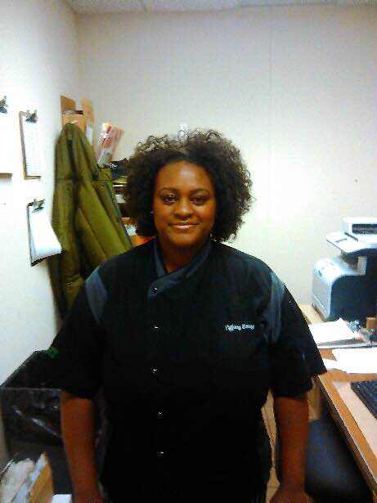



Wow: worker of the week

Worker of the week goes to Tiffany Bailey, a Retail Dining FSWII at Discovery Park. Tiffany Bailey does an outstanding job on a daily basis.  Always smiling and upbeat.  The busier it gets the harder she works.  Always helping out fellow employees.  Never takes short cuts in her work.  Diligent in her duties such as temping the food, sanitation practices and keeping work areas neat.  When someone calls out leaving us short staffed Tiffany steps it up and gets the job done.  She is an asset to retail dining at Discovery Park.

WHAT’S GOING ON

There’s lots of activity this weekend on campus.  Our Mean Green football team has a chance to get back on track as we continue conference play.  As always, we will be there making sure the folks in Apogee have a great dining experience while cheering the team on.  Tomorrow also is the ribbon-cutting for UNT’s newest dorm, Rawlins Hall.  This is great news for dining service because the more students we have living on campus, the more opportunities we get to feed them.  And that is what we are here for, to feed the Mean Green.

Work tip

Do you know someone who always seems to know what to do? It’s almost impossible to figure out every contingency at work or in life.  Next time a confusing situation presents itself, ask yourself *if I did know what to do, what would I do?*  Many times this little mental trick *does the trick* because our subconscious mind usually dwarfs our conscious mind.  The key is not to freeze.  Trust yourself.

Talent is cheaper than table salt. What separates the talented individual from the

successful one is a lot of hard work.*— Stephen King*

OCT 20, 2014

VOLUME 7 ISSSUE 7