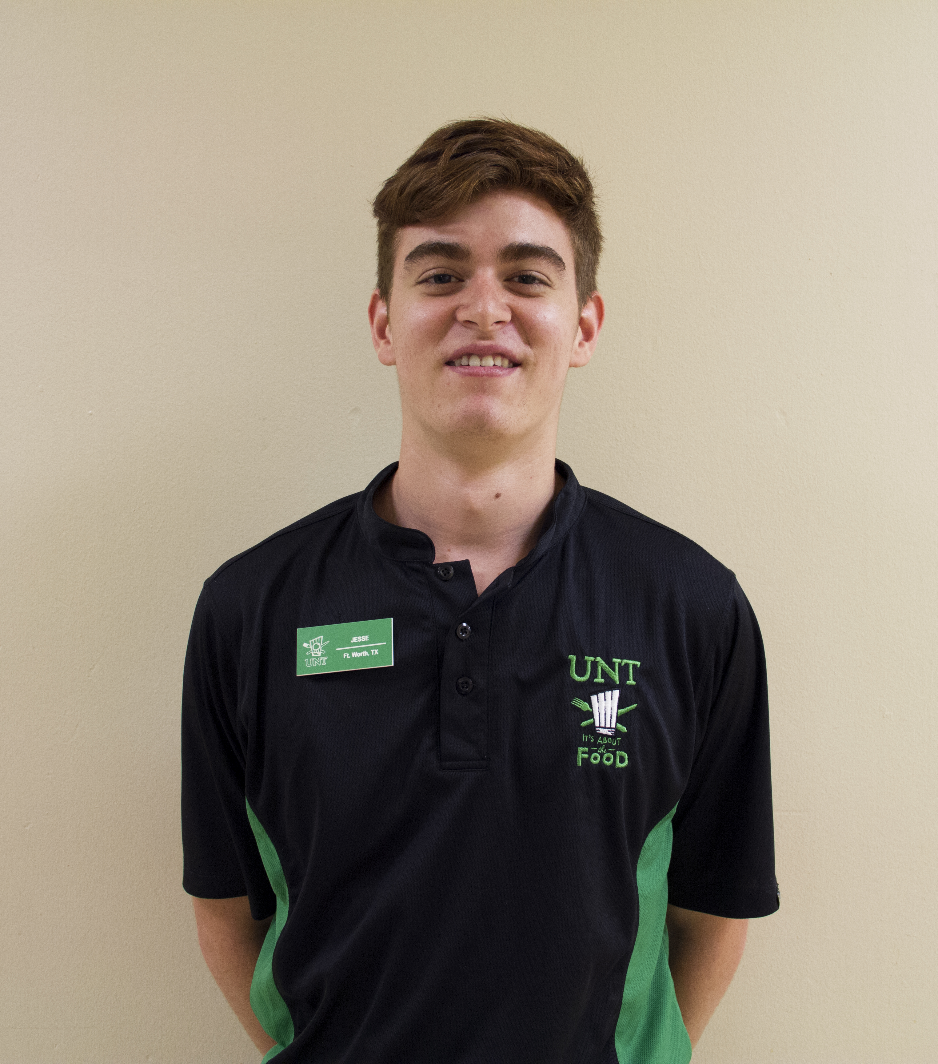

WHAT’S GOING ON

Who turned the lights out?  Check out your dining rooms starting Sunday dinner.  We finally Fall back to Central Standard Time.  It will be dark before you know it.  Homecoming is this week.  We have a campus wide cookout on Tuesday and the game is on Saturday.  The team needs support.  We need to win the final four to make a bowl appearance.  That’s a lot of pressure.



Work tip

Do you know someone who never makes mistakes?  Maybe it’s you?  I hope not.  Mistakes are a part of learning.  If you ever want to be good at something, you must be willing to suck at it first.  The key is to make sure to actually learn from your mistakes and not to keep making the same ones time after time.  Yes, mistakes are a huge part of every successful person and every successful venture.  Show me someone who never makes mistakes and I’ll show you someone who never does anything.

Wow: worker of the week

Jesse Sloan has been a great advantage to the Verde team since day one.  His work ethic is outstanding – always asking what can be done next, how he can improve, and volunteering to mop at the end of the night!  His attitude is always positive and upbeat, and he takes the time to learn how to do things the right way.  We are very happy to have Jesse as a Verde team member!

*Most of what we call management consists of making it difficult for people to get their work done.*

*—* Peter F. Drucker

OCT 31, 2014

VOLUME 7 ISSSUE 9