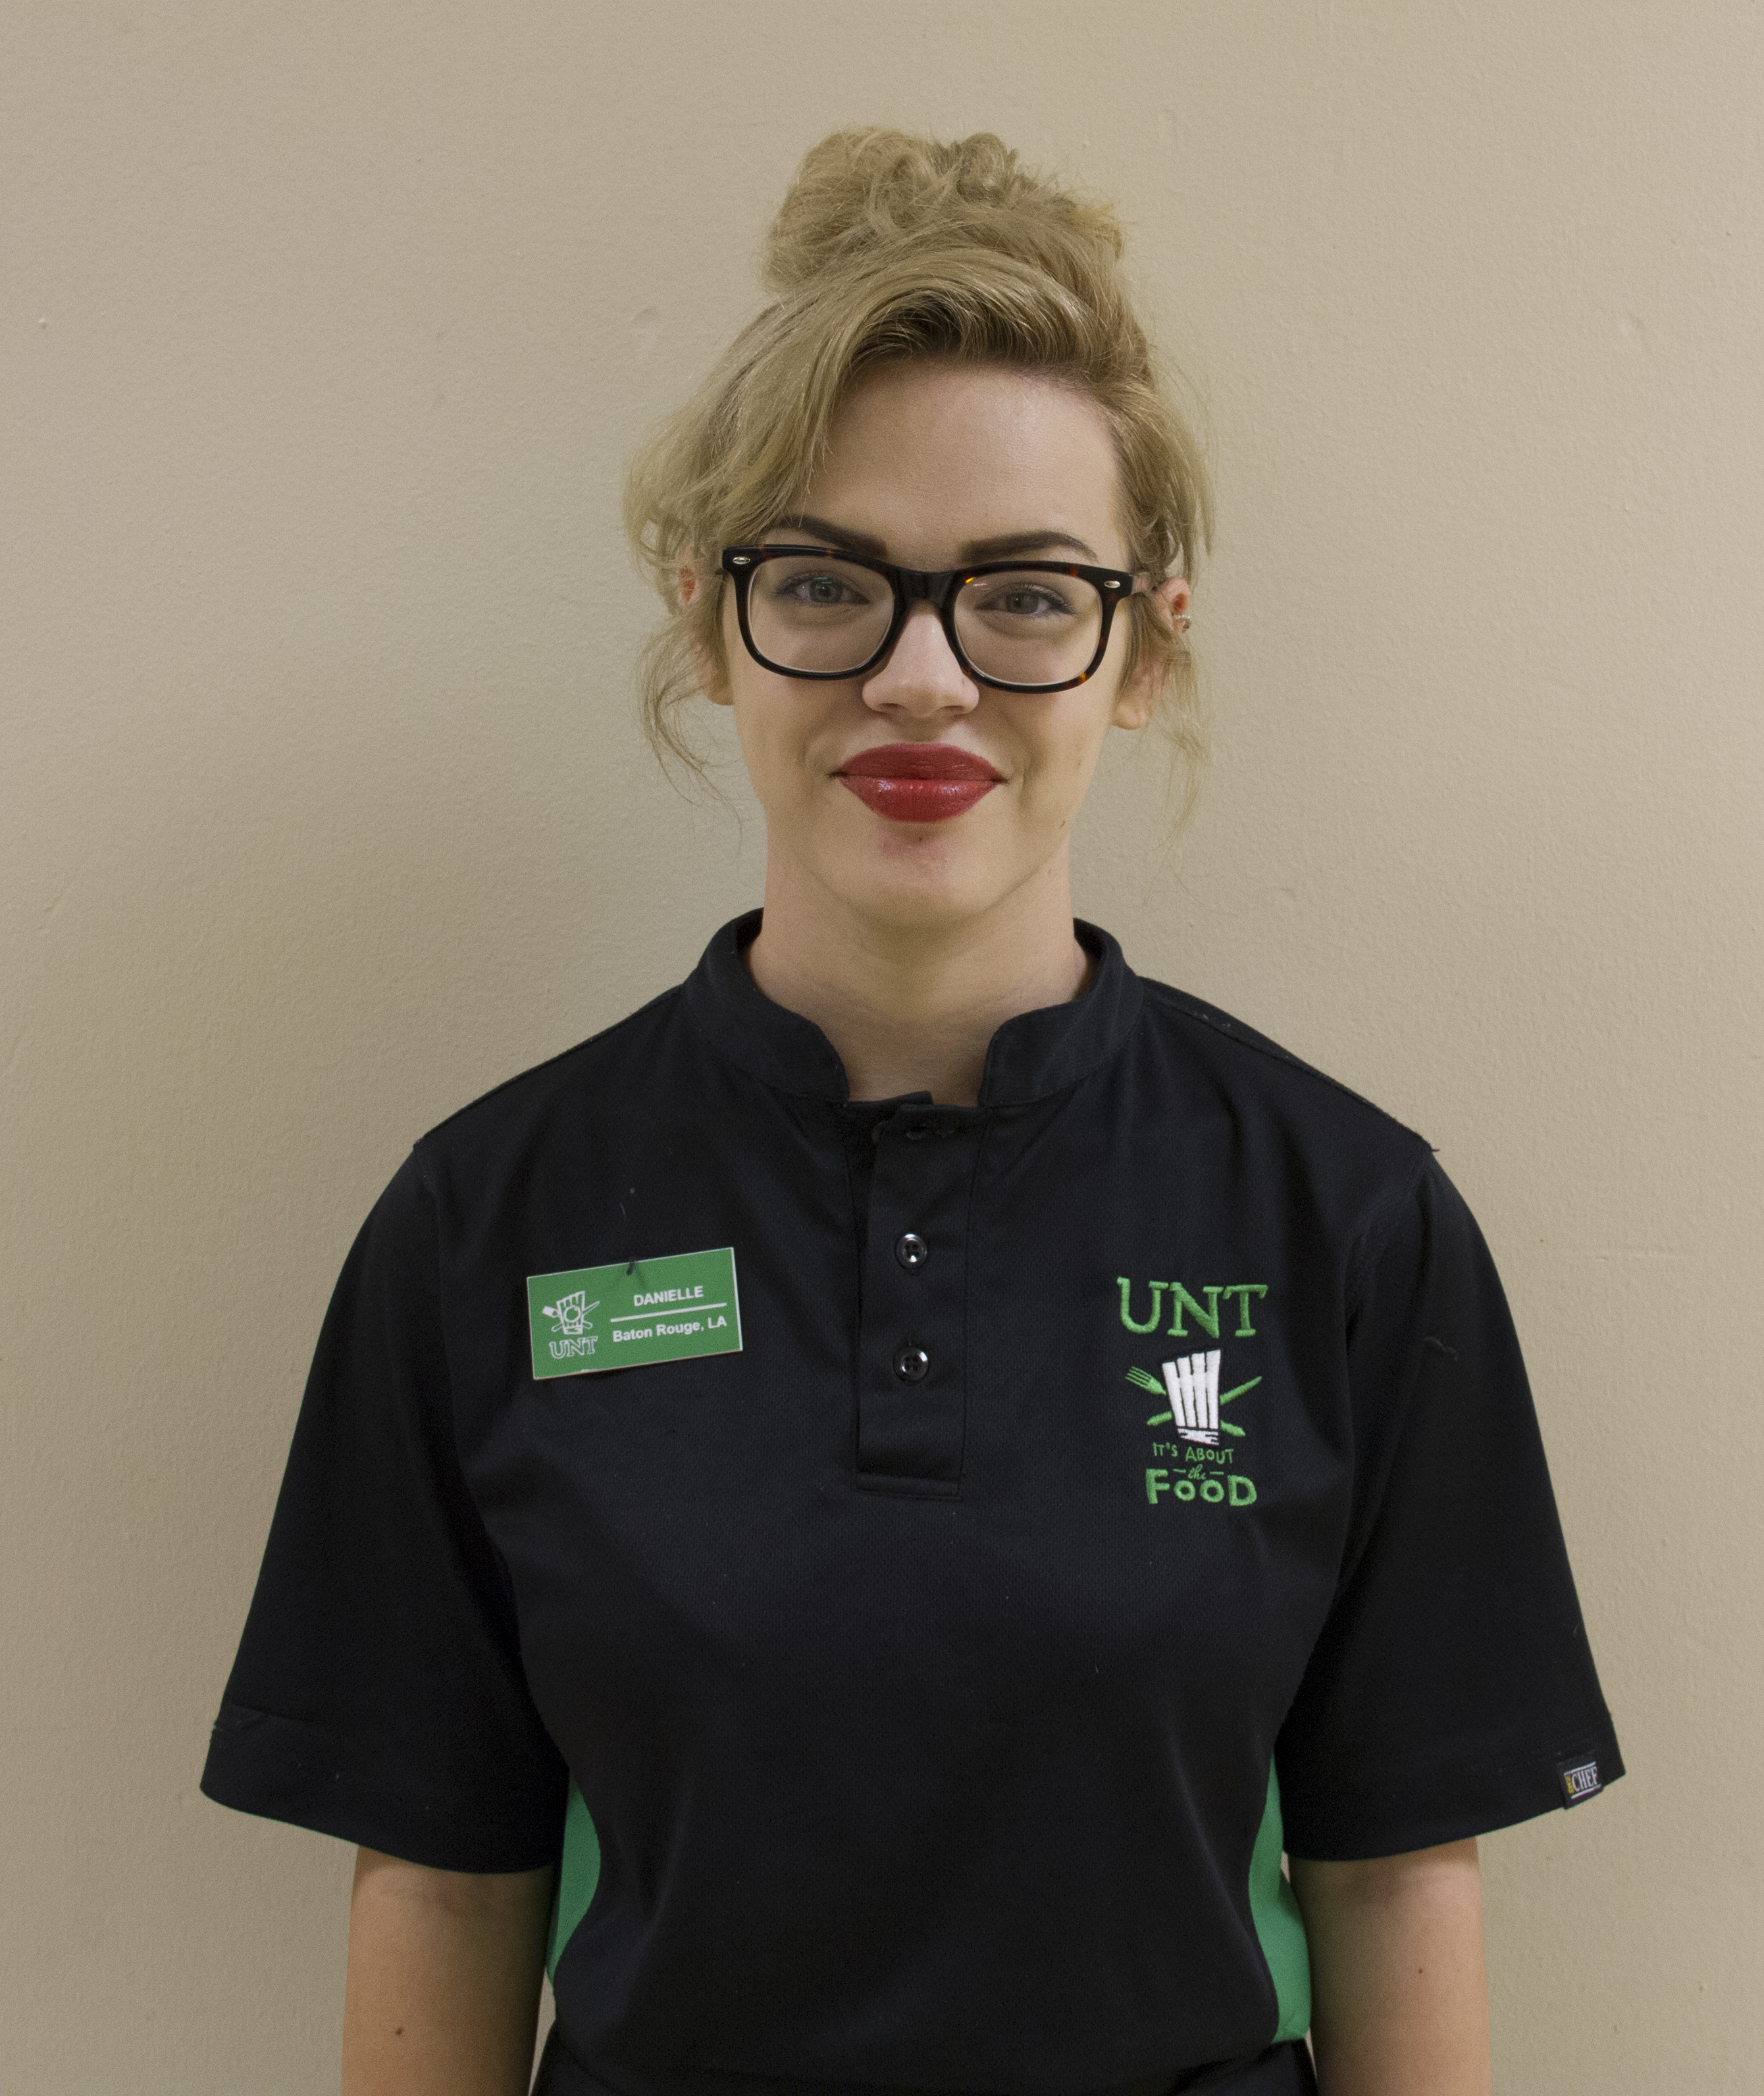

WHAT’S GOING ON

Merit raises.  For some full time employees.  Here’s the breakdown:  we have 1% to spread around.  It is a *merit* increase, *not a cost of living* increase.  That means you have to do more - a lot more- than just show up.  *New Hires*, *Recent Promotions* and *Disciplinary Cases* (HRM-19s) are ineligible.  If you receive 0% increase, it does not mean you did a bad job, it means you did not rise to the standard of *merit*.  If you receive 1%, then you met the merit standard.  If your increase is above 1%, then you surpassed the merit standard.  Merit increases are scheduled to begin in November.  The time to start earning next year’s merit is now.



Wow: worker of the week

Danielle has only worked with us at Verde Catering for a short while but has already been noticed by her managers, peers and guests to have an outstanding attitude and eagerness to learn.  She consistently asks what can be done next, and shows that she cares about the job we’ve laid out for her…and with an upbeat attitude!  Thank you Danielle!

Work tip

Most people don’t work in college food service with the thought of getting rich quick.  It is a long-term play.  Modest salaries with modest increases over a long stretch of time supplemented with good employer paid benefits is the financial reward.  Maximize your pay by maximizing your value.  Figure out what your boss most needs from you, then figure out how to deliver it…day in and day out.  Supervisors need employees that don’t need constant supervision to ensure the job is done properly.  Figure out how to do your job…every aspect of it…then get busy doing it.  That’s how to earn merit raises.

*Management by objective works - if you know the objectives. Ninety percent of the time you don't.*

*—* Peter Drucker

OCT 24, 2014

VOLUME 7 ISSSUE 8